karthikeyan sugumaran

Created By: Karthikeyan@Shankarkumar S

Group ID: 6

Student ID: 2020CFSE008

Taxila’s Learning management System-Web App using React JS

***Taxila's Learning Management System***

# **GitHub Link:**

<https://github.com/karthikeyansuku/ReactAppWorkspace.git>

# **Description of features implemented**

1. Login: username and password validations are added. Invalid and successful logins are implemented with alert notification.
2. Registration: Implemented input field value validations. redirecting to login page if user decide. Alert notification on successful registration.
3. Faculty dashboard: Faculty user can view list of courses assigned to them and can able to view list of students enrolled and list of students registered for the course. Faulty user can able to view add module and evaluation component to the courses assigned to them. Sign out to terminate user session and redirect to login page.
4. Students enrolled: Faculty user can able to view students’ details (who all are enrolled for the course) from faculty dashboard. Button for Go back to faculty page and sign out to terminate user session and redirect to login page.
5. Students registered: Faculty user can able to view students’ details (who all are registered for the course) from faculty dashboard. Button for Go back to faculty page and sign out to terminate user session and redirect to login page.
6. Module creation: From faculty dashboard, Faculty user can able to add new module to the course assigned to them. Button for Go back to faculty page and sign out to terminate user session and redirect to login page.
7. Evaluation component creation: From faculty dashboard, Faculty user can able to create quiz/online exam/assignment to evaluate students’ understandings. Button for Go back to faculty page and sign out to terminate user session and redirect to login page.

# **UserCases**

## **EPIC 1: Login/Registration**

### Registration:

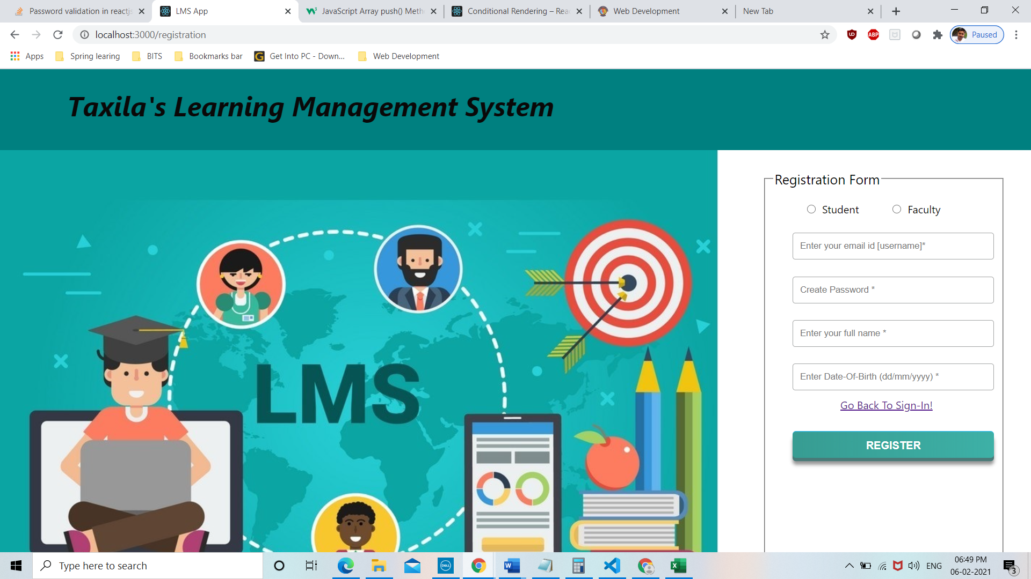

Password Criteria & Field Validation error:

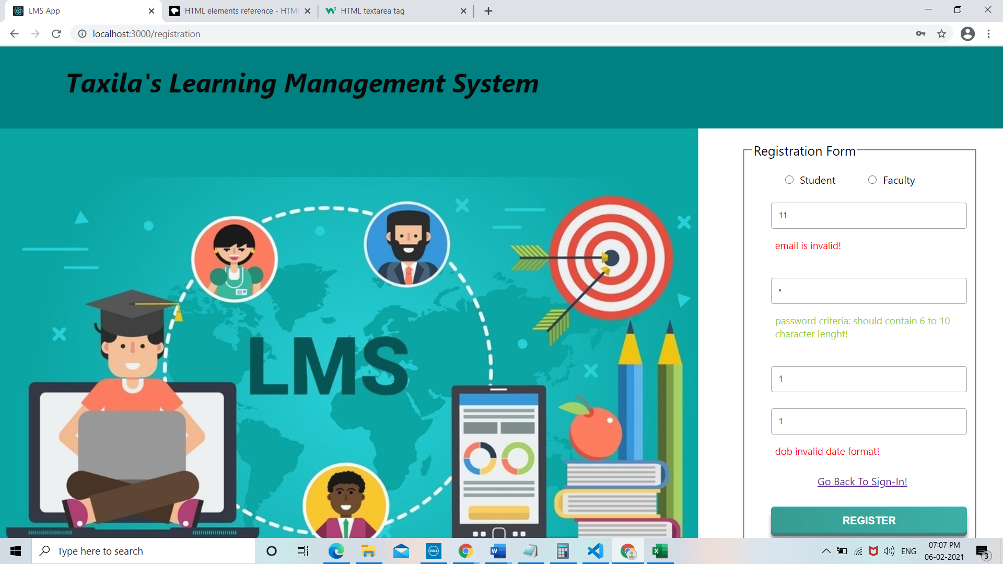

Successful registration:

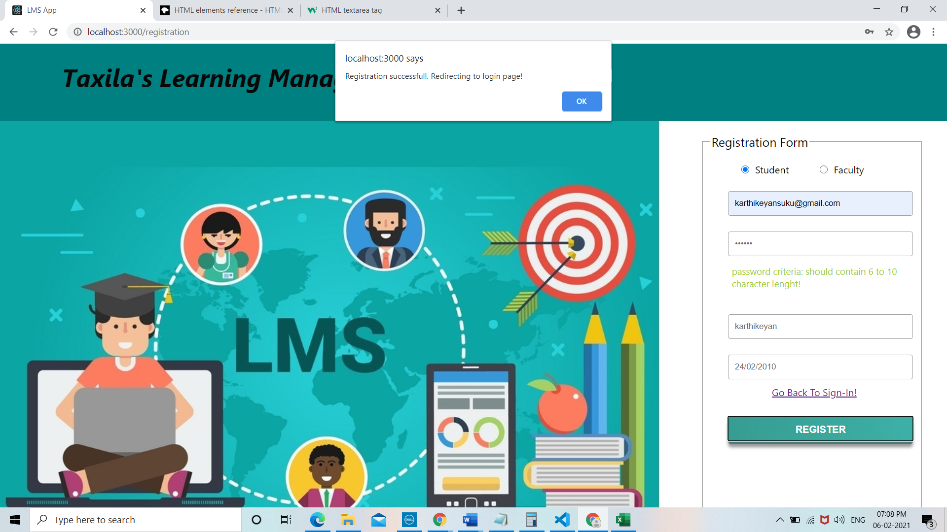

### Login:

Validation error:

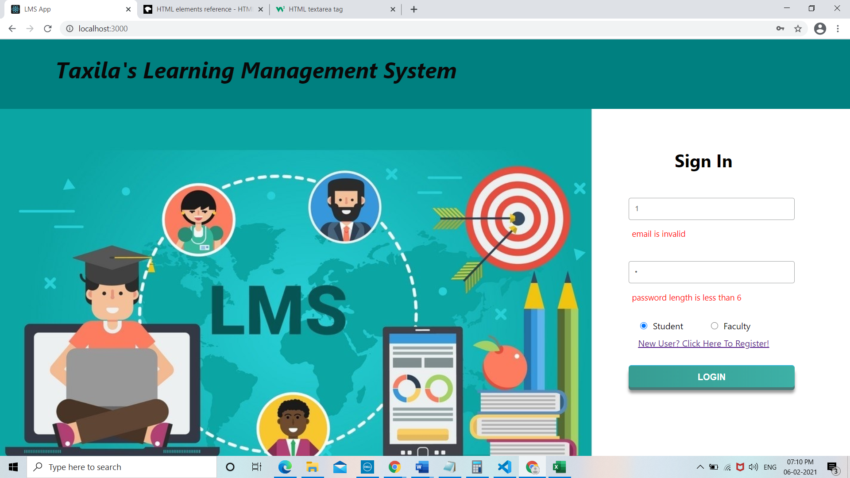

Login failure:

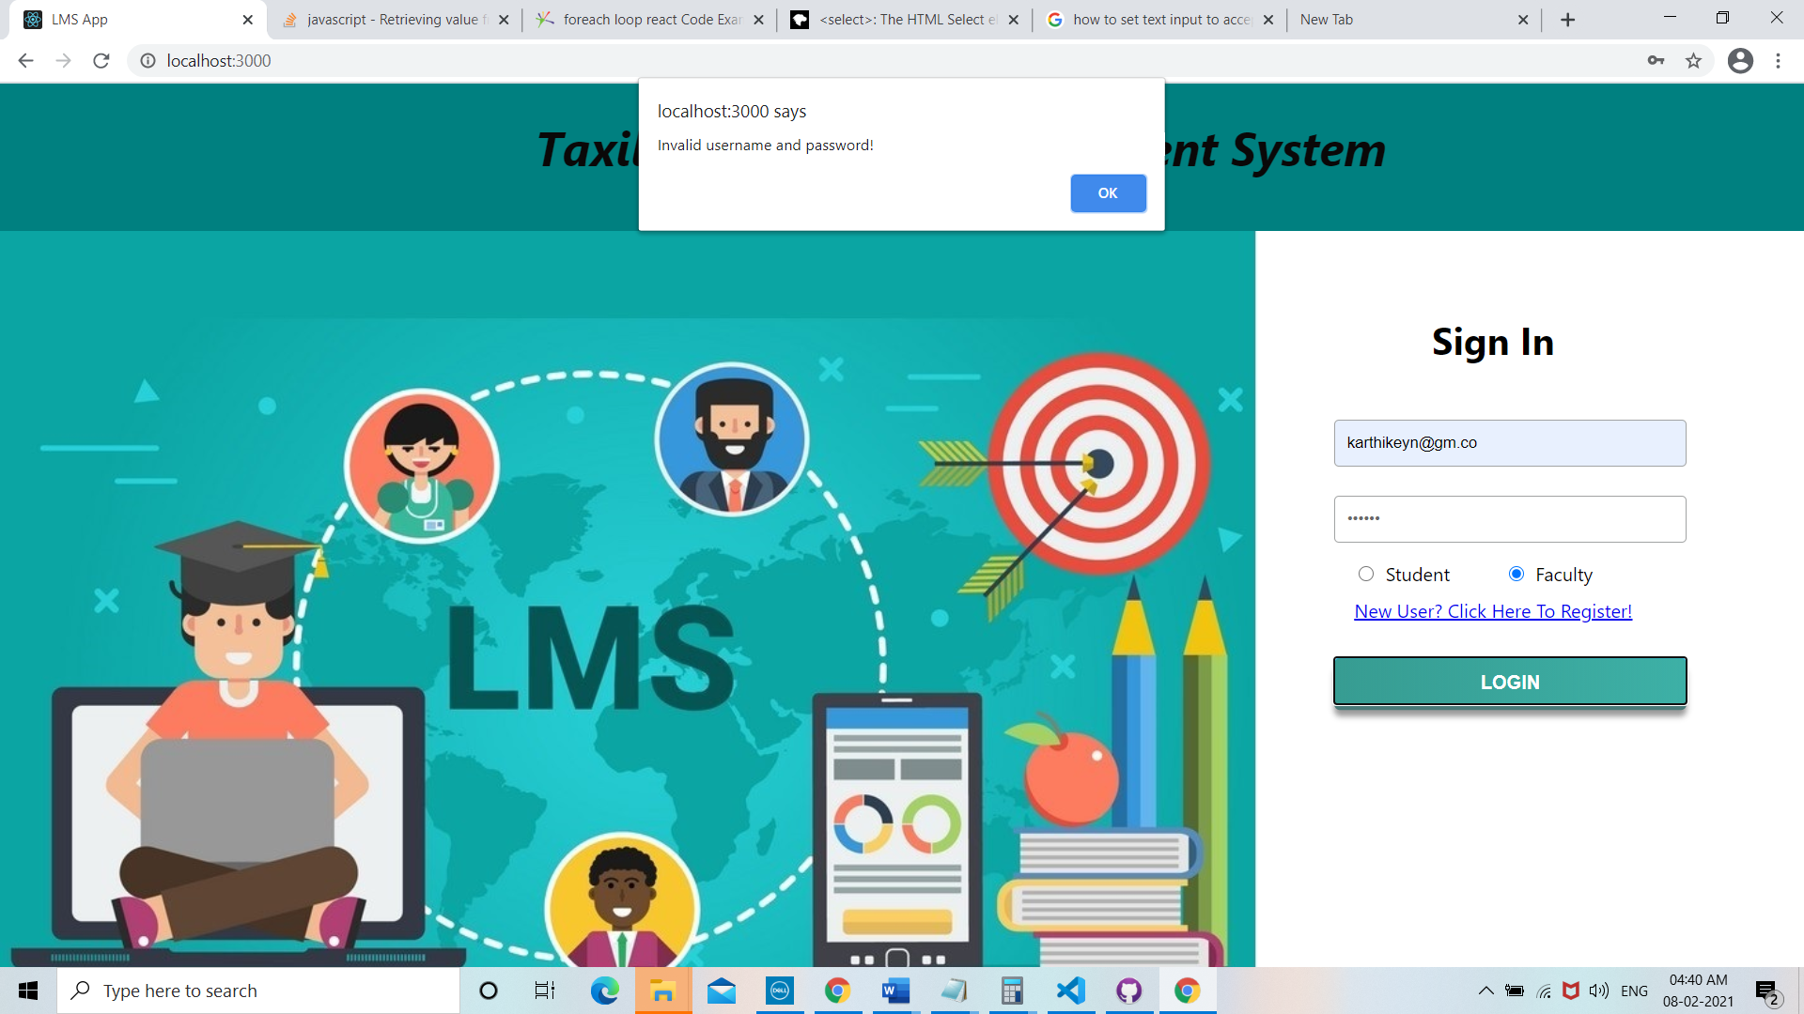

Login success:

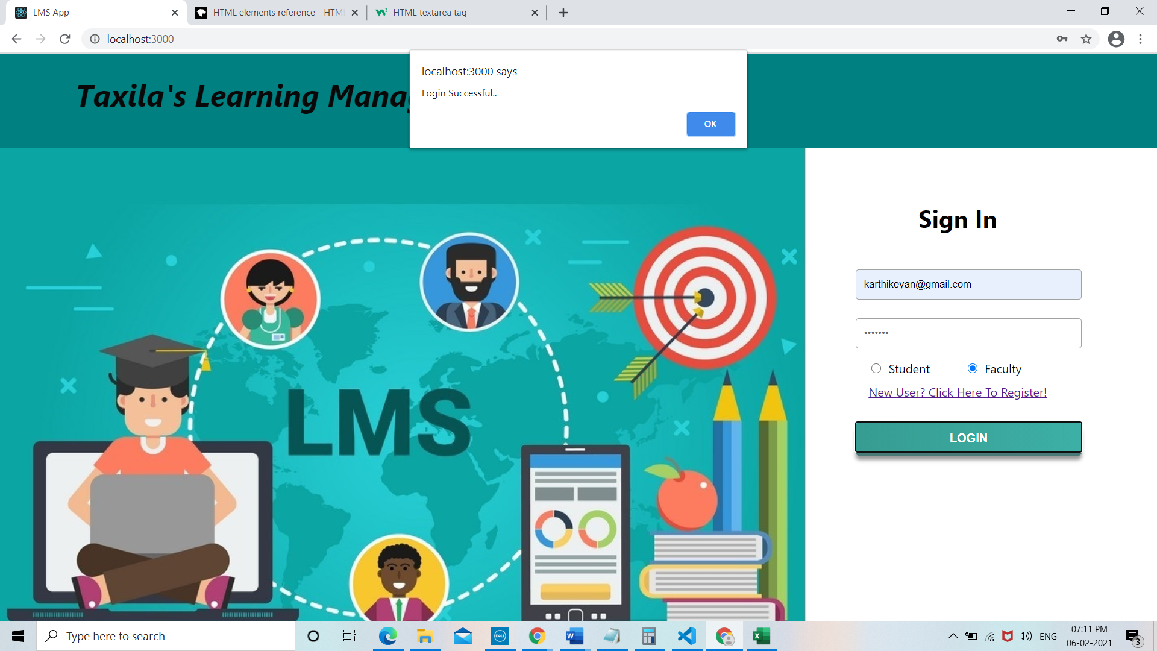

Redirected to Faculty Dashboard:

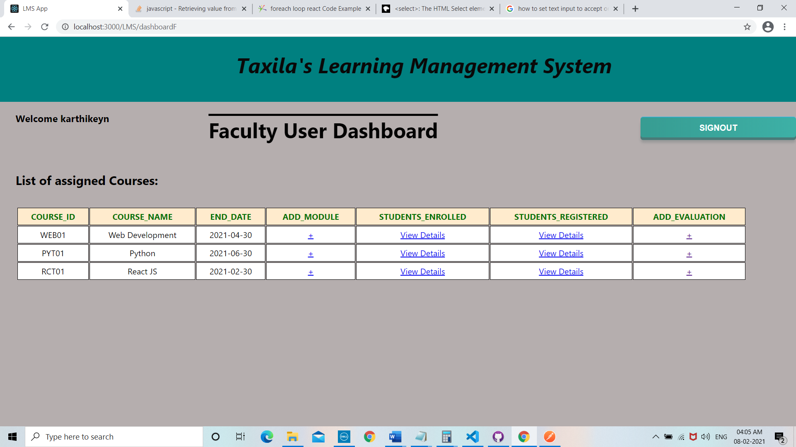

## EPIC 3: FACULTY FLOW

### 3.1) Faculty Dashboard:



Without Course assigned:

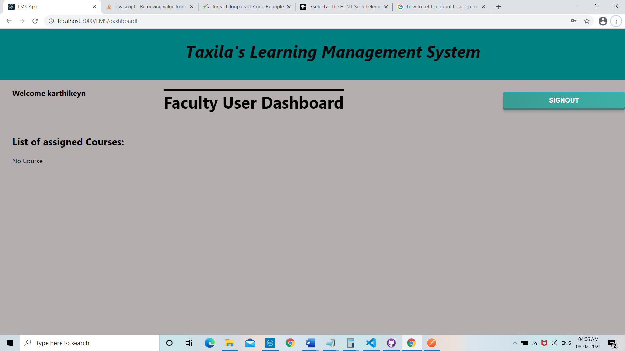

### 3.2) Course Details:

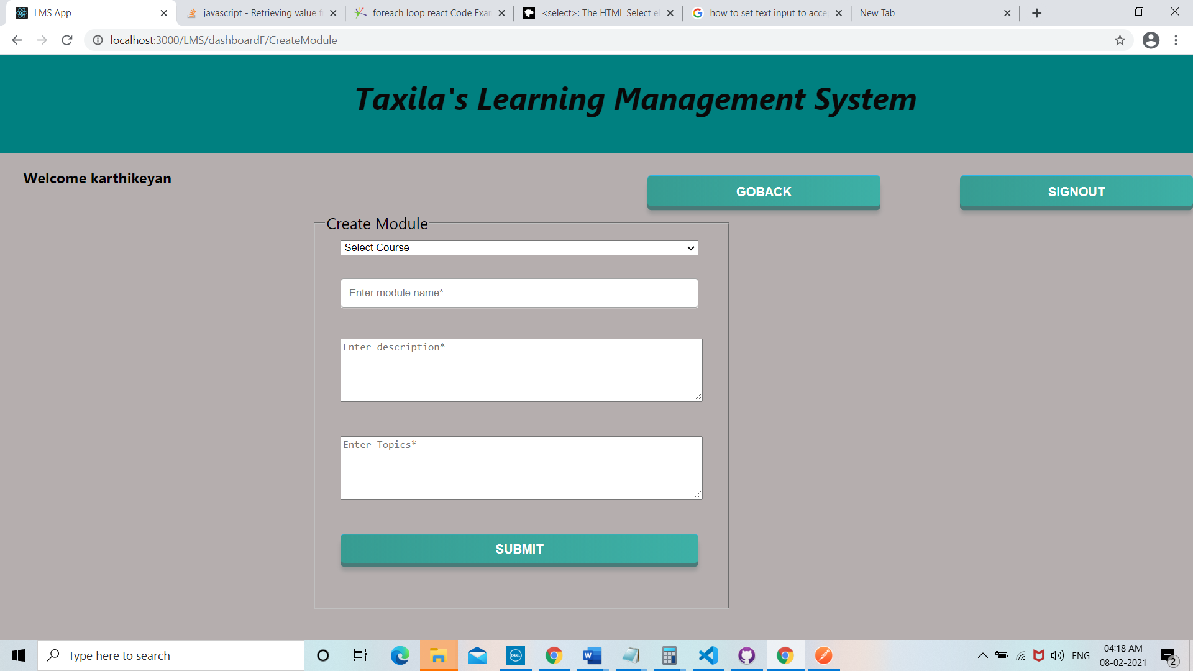

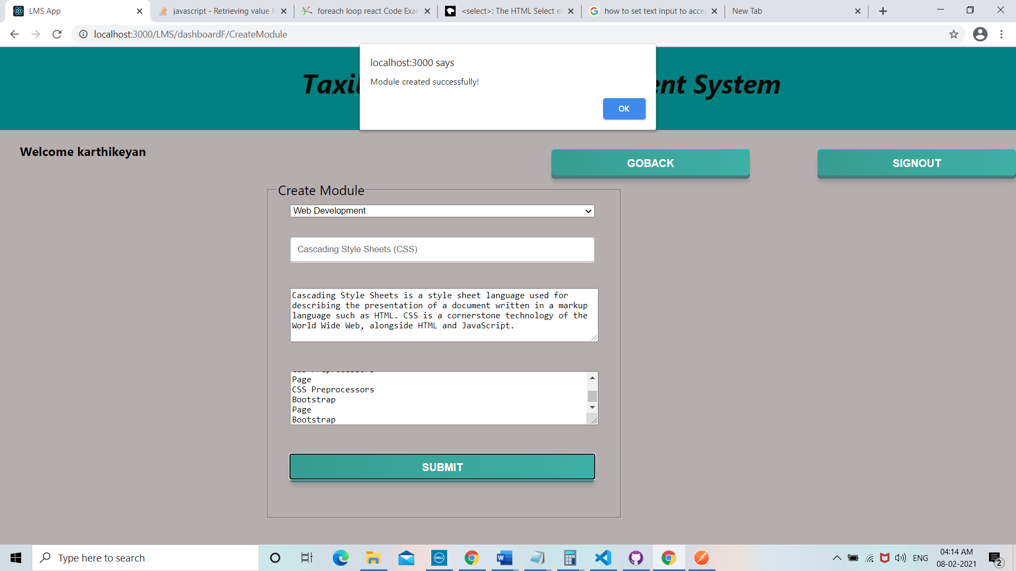

### 3.3) Student Details:

Enrolled Students:

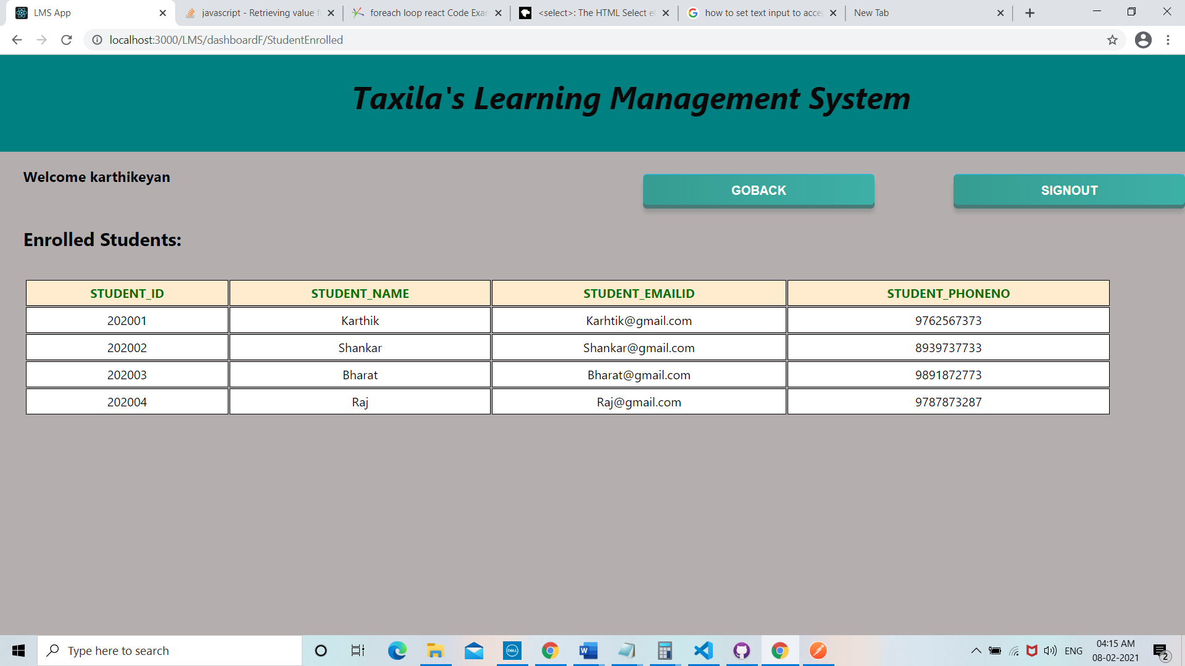

Registered students:

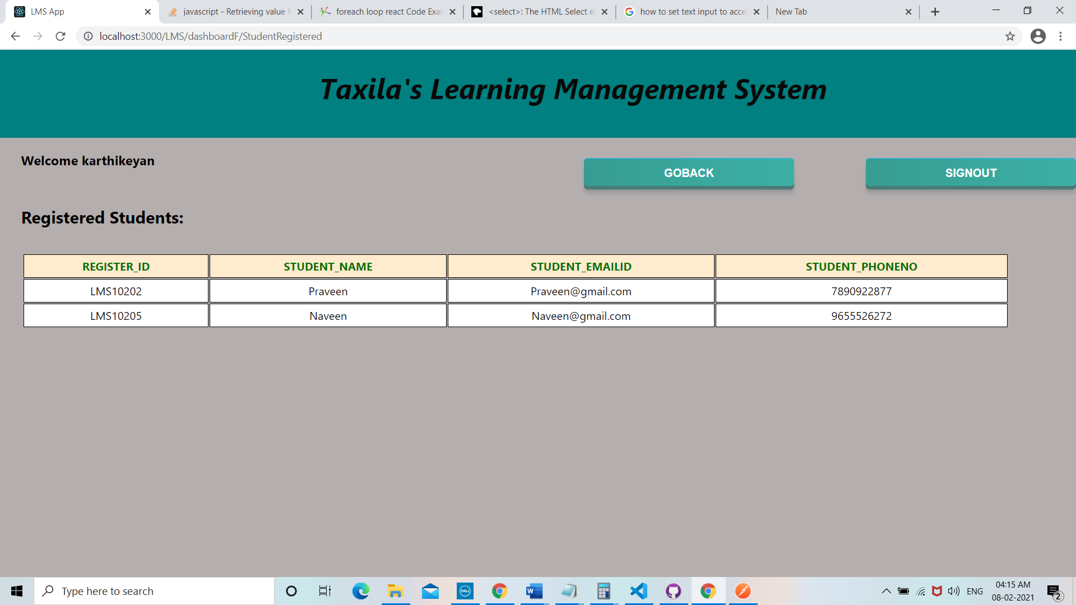

### 3.4) Add Evaluation component:

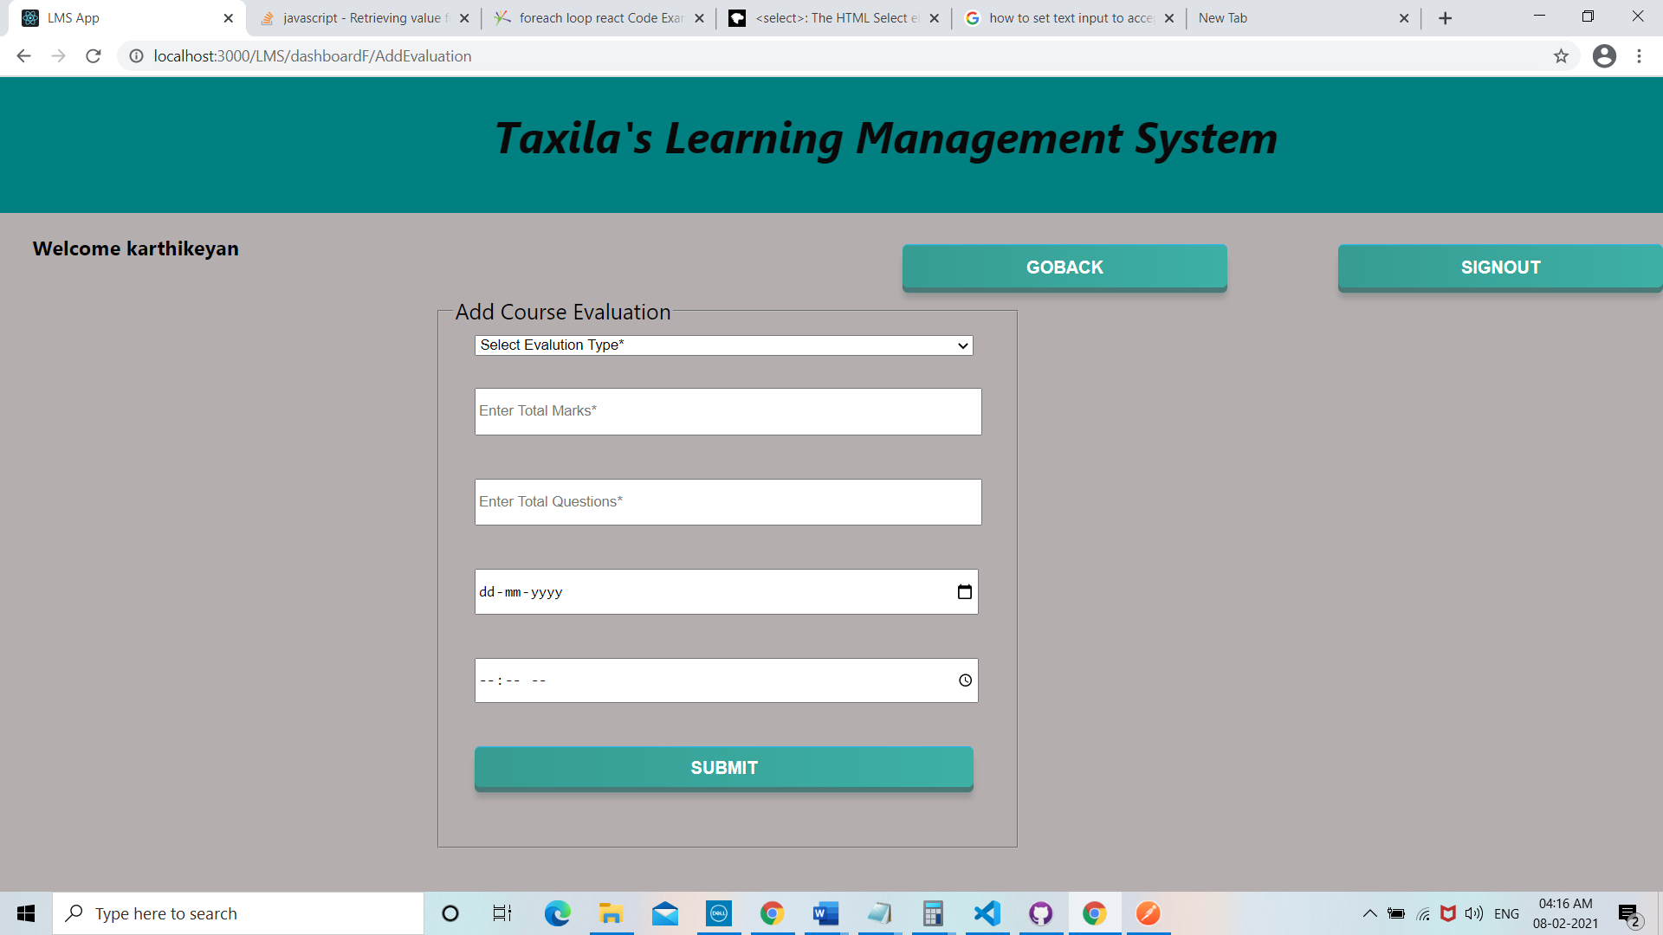

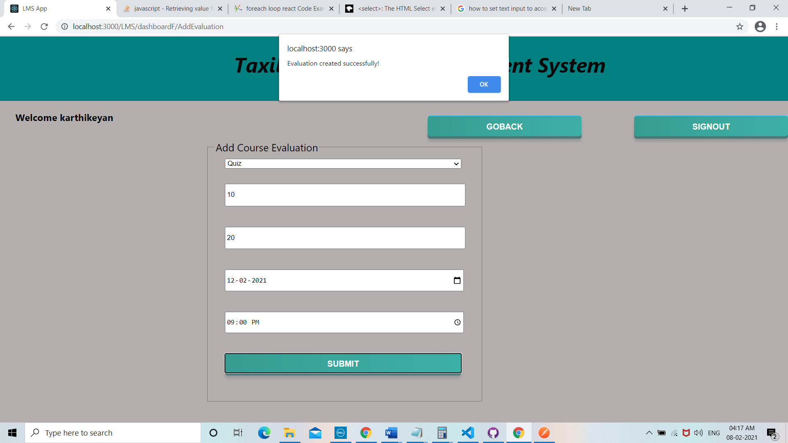

# Execution instructions:

1. Checkout the code from git and in terminal type “npm start” to start the application.
2. Hit <http://localhost:3000/> for login page.
3. Failure login: enter any username and password for getting “Invalid username and password” alert.
4. Success login: enter username as [karthikeyan@gmail.com](mailto:karthikeyan@gmail.com) and password “kar1990”.
5. In faculty dashboard, from any of assigned courses:
   1. click ‘+’ symbol under add module column to redirect to Course module creation view.
   2. click ‘+’ symbol under add evaluation column to redirect to Add Course Evaluation creation view.
   3. click ‘view details’ symbol under add student registered column to redirect to registered student details view.
   4. click ‘view details’ symbol under add student registered column to redirect to registered student details view.